«Display_Name»
Using Blender 2.7 for Animation - Advanced 1.1 - Physics
GOAL: Make a simulation of an object falling onto a floor, then record it and make a video.
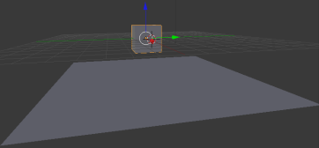
Each physics simulation usually has at least two parts: a Static object for the floor, & a Rigid Body to fall or be pushed.
- Save As, click home drive (such as T:\username or H:, or Documents if none), then in second box name it 3dad1
- Start by making a floor (such as Add, Mesh, Plane), & any mesh such as a Cube above it (not touching):

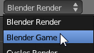
To use physics, you need to be in the Blender Game engine.
Click Blender Render at the top and change it to Blender Game:

In the Blender Game engine, the physics tab looks different. Make the right pane bigger by dragging the black line so that you can see the physics button:
Can’t see physics button? | Drag black line over so you can see physics button.

- Click the Physics button

- Select the cube or other object that will fall.
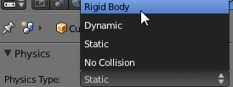
- Change Physics Type to Rigid Body:

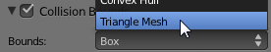
- Check “Collision Bounds” then change Bounds to Triangle Mesh (other types of Bounds use less of the computer’s speed but reduce accuracy) :

- Repeat these steps for the floor, except leave Physics Type as Static (instead of Rigid Body) so it doesn’t move.

After you are done setting up the simulation, move the mouse pointer onto the 3D View then press the ‘p’ key to play.
When you are done viewing the simulation and need to use the mouse, press
“Esc” (escape) key to exit the simulation.

Advanced 1.2 - Controllers (how to be a puppeteer)
To combine animation and physics, you need to program the objects instead of adding keyframes (since the simulation is interactive). For example, you can make a “Baseball Bat” then program it so that the object rotates when you hit the Ctrl key on the keyboard. A Sensor detects a keypress, button, or other event, Controller groups keys, and Actuator is what happens (such as swinging the baseball bat)
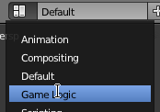
- Add, Mesh, Cylinder or other, to make an object the user will control.
- For screen layout, change from Default to Game Logic (see picture)
- Make sure the object that you want to control using the keyboard is selected (such as a baseball bat), then Click “Add Sensor”, “Keyboard”
- Now set which key will control the object (just click the blank box—see first pic below—then press any key such as the right Ctrl key):
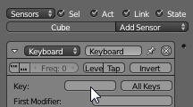 | (That will cause Right Ctrl to control the object)
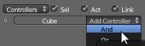
- Click “Add Controller”, “Or”
(all the controller does is combine keys. For example, you can choose “Or” then connect more than one key so each do the same thing)

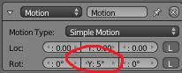
- Click “Add Actuator”, “Motion”.
- Drag to draw lines to connect the sensor to the controller:
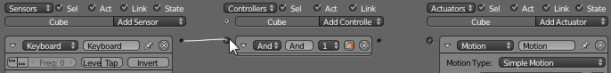
- And controller to actuator:
- Next you must choose how the actuator affects the motion of the object: Under the “Motion” actuator, change the values for how much you want the keypress to affect the object—about 5 degrees moves fast enough (example shows 5 degrees on y so the z axis [ends] swings like a baseball bat).

Advanced 1.3 - Recording & Rendering Simulations
If you want to render a simulation to a video file, you would record the simulation, including your “puppetry” (such as using the Ctrl key) to an animation.
- In Blender Game engine, click Game (at top) then make sure “Record Animation” is checked
- Press ‘p’ to play simulation
- Press Ctrl to control your object to play your part as puppeteer (or whatever key you added to the Sensor)
- When simulation has run enough (a few seconds or whenever you are finished) press “Esc” key
- Change engine to Blender Render 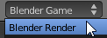 (at top of screen)
- Click Render button 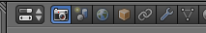
- For Render Presets choose HDTV 720p. Under output change /tmp to T:\username\3dad1 video and Change PNG to H.264. At the top of the screen click Render, Render animation
TIPS
- After checking record & pushing ‘p’, the only way to PLAY is to change from Blender Game to Blender Render,
then (jump to beginning, play).
- After checking record & pushing ‘p’, The only way to ERASE is to change the timeline to a Dopesheet view
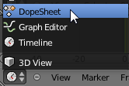 then place the mouse over the dopesheet, then hit the ‘a’ key a couple times to select all (make sure all of the diamonds are orange) then Delete key, Enter key (then you can change the view back to a Timeline, by clicking on it again like the picture above except choosing Timeline)

Overview
- Have at least 1 Static object, 1 Rigid Body, and 1 working Actuator that controls the object with a key (can be same as static object if you want the floor to move)
- Record the simulation, using the Ctrl key to puppeteer before you press Esc to stop recording
- Render Animation: see settings above or Computer, Resources: “R:\Classes\3DAnimation\ANIMATION SETTINGS for all Blender projects (except change Output part number to which one we are on).docx”

